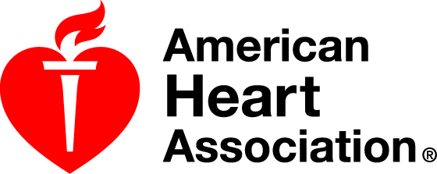

American Heart Association Emergency Cardiovascular Care Programs
Basic Life Support (BLS)
Course Roster

Course Information
□ New Course /Provider Lead Instructor ___________________________________________
□ Update Course/Renewal
□ Instructor Status Renewal Date _______________________________________
Training Center___________HOLY CROSS HOSPITAL_________
Training Center ID# ___________MD01573____________
Training Site Name (if applicable) _____________________________
Course Location ___________________________________________
Address __________________________________________________
City, State ZIP _____________________________________________

Course Start Date/Time _______________ Course End Date/Time _________________ Total Hours of Instruction __________

No. of Cards Issued _________ Student-Manikin Ratio __________ Issue Date of eCards ________________

Assisting Instructors (Attach copy of instructor card for instructors aligned with a TC other than the primary TC)
Name and Instructor ID# Card Exp. Date | Name and Instructor ID# Card Exp. Date
1. | 5.
2. | 6.
3. | 7.
4. | 8.
I verify that this information is accurate and truthful and that it may be confirmed. This course was taught in accordance with AHA guidelines.
____________________________________________ _______________________________________________
Signature of Lead Instructor Date
Date ____/_____/ 2019 Course BLS ____________ Lead Instructor _____________________________________
Course Participants
Name and Email  Please PRINT your name as it will appear on your eCard. Please | EMAIL ADDRESS  print email address legibly. | Telephone | Complete  /  In  complete | Test  Score | Remediation/Date Completed  (if applicable)
1.Name: Terry White | whitete@holycrosshealth.org | 240  988-8755 | C | 100%
1.
2.
3.
4.
5.
6.
7.
8.
9.
10.

